Orson Welles (1915-1985)
Luis Miguel García Mainar (University of Zaragoza)

Orson Welles was born on May 6, 1915 in Kenosha, Wisconsin, to Richard Head Welles, a prosperous wagon manufacturer and inventor, and Beatrice Ives Welles, a gifted concert pianist. Noted for a deep resonant voice, imposing personality and overflowing talent, he was an actor, director, writer and producer in theatre, radio and film. Welles succeeded in innovating in all those fields but left his mark mostly on cinema with a series of stylistically original films. His Citizen Kane recounted the life of newspaper mogul Charles Foster Kane, fashioned after media magnate William Randolph Hearst, from five different points of view. Made for RKO in 1941, it has been placed at the top of “Best Films” lists by critics and specialised magazines ever since. Citizen Kane was followed by The Magnificent Ambersons (1942), a story about declining family fortunes and the rise of the automobile that echoed his own life. Welles’s films were praised for their ingenious techniques—long takes and compositions in depth that reinforced realism and gave spectators the freedom to scan the scene in ways that classical editing did not allow, while also producing a stylised, unnatural cinema (Bazin 2005; 1991, 64-82; Naremore 1989, 35).
Welles started directing and acting already in his teenage years at the Todd School for Boys, where he developed a special interest in Shakespeare. After the divorce and death of his parents, Welles was sent to Ireland to study painting but instead obtained his first professional role at the Dublin Gate Theatre. Back in the United States he kept acting in plays until in 1937 he and John Houseman established the Mercury Theatre, one of the Federal Theatre companies in New York, where he staged a revolutionary version of Julius Caesar that made him immensely popular. By that time he was also known for his work on radio: in programs such as The March of Time, The Shadow, in his own show First Person Singular, and in The Mercury Theatre on the Air, whose extraordinarily realistic version of The War of the Worlds threw Americans into a panic (http://archive.org/details/OrsonWellesMrBruns). Pursuing also an early interest in cinema, Welles took his Mercury Theatre actors to Hollywood to make Citizen Kane and The Magnificent Ambersons, followed by three films that failed at the box office: The Lady from Shanghai (1946), The Stranger (1946) and Macbeth (1948). To the eyes of Hollywood, this trilogy about power and its consequences revealed him as an eccentric, unreliable director, and he did not make another Hollywood film for a decade.
Alienated from the movie world and the society of the United States, he moved to Europe, where production costs were lower, and continued his career as an actor to finance films of a bizarre style such as Othello (1952) (http://archive.org/details/FilmingOtheloByOrsonWelles), Mr. Arkadin (1955), The Trial (1962), and the Shakespeare-based Chimes at Midnight (1966). During this period, Welles returned to Hollywood to make the expressionistic Touch of Evil in 1958, but then worked mainly as an actor until his death at age 70. His ashes were taken to Spain and buried in the country house of bullfighter Antonio Ordóñez.

References and further reading
Bazin, A. (2005) ‘The Evolution of the Language of Cinema’, 23-40, What Is Cinema? Vol. 1, trans. by Hugh Gray. Berkeley: U of California P.
Bazin, A. (1991) Orson Welles: A Critical View, Venice CA: Acrobat Books.
Berg, C. and T. Erskine (2003) The Encyclopedia of Orson Welles, New York: Facts On File.
Callow, S. (1995, 2006) Orson Welles: The Road to Xanadu, Orson Welles: Hello Americans, London: Jonathan Cape.
Higham, Ch. (1985) Orson Welles: The Rise and Fall of an American Genius, New York: St. Martin’s Press.
Kael, P. (1971) ‘Raising KANE’, The New Yorker, February 20: 27.
Mulvey, L. (1992) Citizen Kane, London: BFI.
Naremore, J. (1989) The Magic World of Orson Welles (New and Revised Edition), Dallas: Southern Methodist UP.
Rosenbaum, J. (2007) Discovering Orson Welles, Berkeley: U of California P.
Welles, O. and P. Bogdanovich (1992) This is Orson Welles, New York: HarperCollins.

List of works (films directed by Welles)
The Hearts of Age (1934)
Citizen Kane (A Mercury Production/RKO, 1941)
The Magnificent Ambersons (A Mercury Production/RKO, 1942)
The Stranger (International Pictures/RKO, 1946)
The Lady from Shanghai (Columbia, 1946)
Macbeth (A Mercury Production/Republic Studios, 1948)
Othello (A Mercury Production/Scalera Studios, 1952)
Mr. Arkadin (a.k.a. Confidential Report) (A Mercury Production/Sevilla Studios/Film Organization, 1955)
Touch of Evil (Universal, 1958)
The Trial (Paris Europa Films/FI-C-IT/Hisa-Films, 1962)
Chimes at Midnight (Internacional Films Española/Alpine, 1966)
The Immortal Story (ORTF/Albina Films, 1968)
F for Fake (Les Films de l’Astrophore/Saci/Janus Film, 1973)
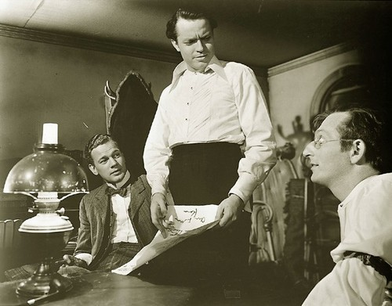
Orson Welles in Citizen Kane.
Source: http://www.moma.org/collection/object.php?object_id=89509

